
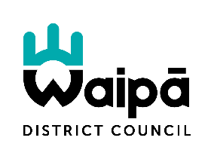

NOTIFICATION OF HEAVY VEHICLE MOVEMENTS
Arnold Street Stockpile

On behalf of Waipā District Council, Downer will be commencing the annual road re-sealing programme from the 21st September. The programme is currently expected to continue through to the 23rd of December, subject to weather conditions, site constraints, and programme requirements.

To support these works, the Arnold Street stockpile site will be used to store and manage sealing chip required to complete the programme. As a result, residents may notice an increase in heavy vehicle movements to and from the site during the season.

To minimise disruption to neighbouring properties, vehicle movements will generally be restricted to the hours of 7:30am to 5:30pm, Monday to Friday. Every effort will be made to manage operations safely and efficiently, while keeping noise, dust, and traffic impacts to a minimum.

The stockpile plays an important role in supporting the delivery of essential road maintenance across the district, helping ensure our roads remain safe and serviceable for all road users.

We appreciate that increased truck movements may cause some temporary inconvenience and thank you in advance for your patience and understanding while these works are underway. Our team will continue to monitor operations and work with the community to minimise any impacts wherever practicable.

For further information, or any special requirements, please contact Adrian Chatfield (Contract Engineer) on either 021 457 275 or adrian.chatfield@downer.co.nz
