District Growth Quarterly Report (Q3)
1 Jan to 31 Mar 2026

Waipa District Council

COMMENTARY - KŌRERO

NATIONAL & REGIONAL LEGISLATION AND POLICY

Resource Management Reforms:
National Direction
The Environment Select Committee completed hearings in February 2026 on the RMA replacement legislation (Planning Bill and Natural Environment Bill). The committee is due to report back to Parliament on 26 June 2026. No advice has been received on when enactment of the bills is expected to occur.

Building Reform Update

Proposed Reforms | Status
Building and Construction Sector (Self-certification by Plumbers and Drainlayers) Amendment Bill | Self-certification will allow trusted plumbers and drainlayers to carry out defined low-risk work without building consent authority inspections. This will reduce inspection delays and allow building consent authorities to focus on higher-risk work. The new legislation is expected to be passed into law mid-2026.
The Building and Construction Sector (Strengthening Occupational Licensing Regimes) Amendment Bill | The Bill will change 3 laws: the Building Act 2004, the Plumbers, Gasfitters, and Drainlayers Act 2006, and the Electricity Act 1992. The Bill had its first reading in Parliament on 18 November 2025. The Bill aims to:  - Improve the disciplinary processes  - Publish details of LBPs whose licences have been suspended for disciplinary reasons.  - Progress work to establish a new waterproofing licence class.  - improving the complaints processes.  The proposed Regulations are expected to be published by the end of 2026.
The Building (Earthquake-prone Buildings) Amendment Bill | The Bill proposes a more risk-based approach, including focusing only on high-risk buildings in high/medium seismic zones and abolishing the use of "earthquake ratings". The proposed Regulations are expected to be published by the end of 2026.

DISTRICT PLAN PROGRAMME

Council-Led Plan Changes
Plan Changes | Status | Timeframes  (Indicative) | Comments
Notified Plan Changes
Proposed Plan Change 25  Shelterbelts and Artificial Crop Protection and Support Structures | Status:  Publicly Notified | Summary of Submissions Notification:  14 May 2026  Hearing:  July / August 2026 | 18 submissions were received on PC25. The summary of submissions and call for further submissions will be publicly notified on 14 May. It is expected that the hearing for PC25 will take place in July / August 2026.

Private Plan Changes
PLAN CHANGES | STATUS | NOTIFICATION (INDICATIVE) | HEARINGS
Draft Private Plan Change 29  Rezone 2025 Ōhaupō Rd from Rural to residential | Status:  On hold awaiting lodgement of Fast Track Substantive Application. | To be determined | To be determined
Draft Private Plan Change 31 - Pokuru Road, Te Awamutu  Rezone T4 Growth Cell from Deferred Residential to Medium Density Residential Zone | Status:  Awaiting Acceptance for Processing (under delegated authority)  Staff have recommended that PC31 accepted for processing and public notification under delegated authority. | June 2026 | To be determined
Draft Private Plan Change 32 – Tabby Tiger  Rezone 33 hectares of land between Raynes and Lochiel Roads from Rural to Airport Business Zone (Agri-Tech Precinct) | Status:  Further Information Requested sent 17 October 2024. Further information yet to be received. | To be determined | To be determined
Proposed Private Plan Change 35 - Te Awamutu Retail Centre  Rezone 4 hectares of land at 638 Cambridge Road from Medium Density Residential to Commercial Zone and consequential rule changes. | Status:  Further Submissions closed 26 February . 2 Further submissions received from the applicant and Foodstuffs Ltd.  Applicant is in discussions with submitters. NZTA no longer wish to be heard. The applicant is currently awaiting flood modelling data from Waikato Regional Council.  Staff have engaged Gray Matter to provide expert traffic assistance.  Hearing intended to be held mid-August subject to commissioner availability. | 16 October 2025 | To be determined
Proposed Private Plan Change 36 – Ōhaupō Large Lot Residential Zone Extension  Rezone 28 hectares of land south of Ryburn Road between SH3 and the NIMT Railway line from Rural to Large Lot Residential | Status:  Further Information Received – 20 March 2026  Further information request sent to applicant on 14 January 2026. The request information was received on 20 March 2026.  PC36 has been accepted for processing and public notification under delegated authority. | June 2026 | To be determined
Proposed Private Plan Change 37 – Rider Park Structure Plan Area  Rezone C5 Growth Cell and adjoining land from Deferred Residential / Rural to residential / medium density residential (Plan Change 28 replacement) | Status:  Submissions Closed – 28 April 2026  275 submissions have been received. The next step is to publicly notify a summary of the submissions and call for further submissions. This is likely to take place in June / July. | 26 March 2026 | To be determined

RESOURCE CONSENTS

Consents Summary
This reporting period showed no change in resource consent numbers with 88 consents processed this period (53 for Land Use and 35 for Subdivision) and also 88 consents processed (55 for Land Use and 33 for Subdivision) the same period last year. All consents this period were processed within the allowable statutory timeframe, except for two. (refer to figure 1).
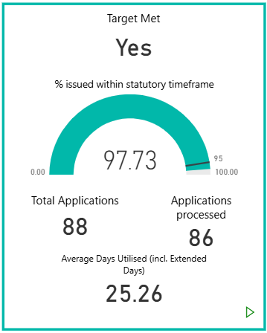
Figure 1: All Resource Consent Applications

Notified Consents
There have been no notified consents during this period.

Environment Court Appeals
There have been no appeals during this period.

Objections Received
There have been no new objections received during this period. The existing objection to application processing costs made by Global Contracting Solutions Limited is yet to be resolved. As an objection to costs was also made to Waikato Regional Council, both councils are corresponding with the objector to resolve the objections.

Consents of Interest
Henley Hotel Retirement Living
Henley Hotel Limited (the applicant or HHL) sought land use consent to construct and operate a retirement village comprising 96 villas and 20 apartments at 151 Maungatautari Road, Cambridge. The site is located within the Rural Zone under the Operative Waipā District Plan. The application was non-notified under staff delegation. In terms of the decision to grant or decline the application, the applicant presented their case to an independent commissioner at a hearing held on 5 December 2025. The application has subsequently been approved with consent conditions.

Land Information Memorandums (LIMS)
LIM volumes increased significantly with 362 processed this period and 274 processed the same period last year. All LIMS were processed within the required statutory timeframes, including all urgent LIMs.

GROWTH AND REGULATORY DEVELOPMENT

There continues to be steady progress in land development projects across the growth cells and interest by way of pre-application meetings also continues. The following tables combine engineering updates from the growth and regulatory areas for each active growth cell (refer to Appendix 1 for the Growth Cell Maps). Updated text shown in RED.
Cambridge Status UPdate
Cambridge North
No update this quarter.
C1
No update this quarter.
C2
A s224c application for Stage 2B of the 3Ms development (Bridleways Estate) is being processed by staff.
A 32-lot subdivision off Te Aka Matua Rise is currently under construction.
Peake Mews (Brian Perry Charitable Trust compact development) - no update this quarter.
The northeastern collector (now Don Gerrand Drive) will look to continue in its construction in conjunction with an approved 87 lot subdivision within the C2 growth cell (SP/0155/22), which will complete the loop of the road to boundary of the greenbelt reserve and loop in Kelly Road. Works are under construction and both IWA portion and subdivision portion are progressing well.
C3
Chartwell development area is continuing construction of the commercial area and residential development. An additional residential resource consent for a 10 lot subdivision have been recently granted.
C4
Construction works on Lamb Street residential subdivision are progressing. No further update about Kaipaki Road roundabout project.
Pedestrian footbridge within Te Awa subdivision (north of Silverwood Lane) is currently under construction and will connect to footpath within Cambridge Park.
C6
No update this quarter.
C8 and C9
Haukiwi (formerly Kama Trust) block is continuing construction works.
C10
No update this quarter.

Hamilton Airport Status update
Northern precinct extension
Construction works are progressing within Northern Precinct.

KARĀPIRO Status update
K1
A 59-lot subdivision in the K1 growth cell has been completed and s224c given.

Pukeatua Status update
P1
Small scale earthworks for a consented residential subdivision development in the P1 growth cell are continuing.

TE AWAMUTU & kIHIKIHI Status update
T1
Physical works for the residential subdivision are progressing slowly currently.
T2
Construction within Arvida retirement village is progressing. No further updates.
T3
No update this quarter.
T4
No update this quarter.
T6
A 32-lot subdivision has been approved by Council staff, and the construction is nearing completion.
T8
Works are underway on an extension of Highfield retirement village.
T9
No update this quarter.
T11
The Waipiko Landing application for further intensification within stage 2 was approved and construction works are underway on the second stage; this stage when complete will create 49 new residential lots.
Negotiation on Development Agreement in regard to cycleway connecting to Park Road have commenced as well.
T12
Construction works are progressing and first stage 224 application is expected in the next quarter.
T15
A 59-lot subdivision for large lot residential properties has been assessed by Council staff and a consenting decision will be issued in the next quarter.
Bond Road
An industrial subdivision has been lodged by the Bond Road developer and is being assessed by Council staff with the developer primarily engaging with Waikato Regional Council staff. Currently on hold and no further updates.

Development Contributions
56 Development Contribution Notices equating to $3,942,636.00 (incl. GST) have been issued. Of those notices generated, there were 18 from Building Consents, six (6) from Project Information Memorandums (Granny Flats exempt from building consents with area less than 70sqm), five (5) from Land Use Consents and 27 from Subdivisions. Main contributors to the notices issued are C2 Development Agreement Charges, medium scale developments in C3 and Cambridge North growth cells and medium-scale residential development across the district.
Recovery for this quarter equates to $6,971,364.00 (incl. GST), which is an increase from the same period in 2024 financial year ($1,971,113.00 incl. GST). Q3 tends to bring substantial revenue generally, as many projects are completed after summer construction season. Largest revenue is derived from Summerset Retirement Village as per Development Agreement within Cambridge North growth cell, 3Ms development as per Development Agreements within C2 growth cell and residential developments within C4 (Te Awa Rise) as per Development Agreement. Recovery is generally in alignment with forecast for the year, given the forecast is linking to mostly development agreements and consents that are of age when completion is expected. For more information on where Development Contributions (DC) have been issued and received relative to our identified funding areas, please refer to “Appendix 3 – Development Contributions by Funding Area”.

Revenue Received $6.97 mill
DC Notices Issued
56
Total DCs issued, yet to be received
$75.18mill
Amount Charged $3.94 mill

Figure 2: Teal shows this quarter specific, orange is overall
Below shows the relationship between total issued DCs and recovered/remaining DC charges over the whole history of Development Contribution Policy (refer to figure 3). We are currently tracking 52% of total issued DCs as recovered and 48% of DCs remaining active charges. For further information about catchment specific DC revenue and outstanding DC charges please refer to “Appendix 3 – Development Contributions by Funding Area”.

Figure 3: DCs Issued vs. Remaining Active DC charges and Recovered DC over the history of Development Contribution Policy

Building Compliance

New Building Consents Issued
A total of 230 building consents were issued between the 1st of January 2026 and the 31st of March 2026. This is an 6% decrease from the 245 issued during the same period in 2025.

Figure 4: Building Consents Issued

Code Compliance Certificates Issued
A total of 198 code compliance certificates were issued between the 1st of January 2026 and the 31st of March 2026. This is an 11% increase from the 179 issued during the same period in 2025.

Figure 5: Code Compliance Certificates Issued

New Dwellings
A total of 43 building consents were issued for New Dwellings between the 1st of January 2026 and the 31st of March 2026. This is a decrease from the 61 issued during the same period in 2025. Figure 6 below shows the dwellings by location Cambridge and Leamington, Te Awamutu & Kihikihi, and the rest of Waipā.

Figure 6: Building Consents Issued

Total value of building work
An estimated total of $77,550,000.00 worth of building work was consented between the 1st of January 2026 and the 31st of March 2026. This is a 16% decrease from the $91,850,000.00 consented during the same period in 2025.

Figure 7: Total dollar value of building work

Building Consents of Interest
No building consents of significant interest were issued between the 1st of January 2026 and the 31st of March 2026. Significant building consents include projects where the estimated project value exceeds five million dollars, or the building may be considered a particular significance to the community.

MONITORING AND ENFORCEMENT
In total Council’s Enforcement team responded to 91 complaints and queries regarding Planning issues. This comprised of 75 complaints regarding breaches of the District Plan and 16 complaints about the potential breach of Resource Consents conditions.
District Plan complaints received concerned amenity values, earthworks, home occupations.
Most District Plan / Resource Consent queries were responded to within four days as required by one of the Team’s KPIs.
A further 18 queries regarding swimming pool barriers were also received and responded to. During the quarter a total of 117 swimming pool barrier inspections were conducted.
212 customer queries were received regarding Council’s Bylaws and potential breaches. This included 78 complaints / queries specifically regarding parking offences.
A further 27 calls were received appealing against the issued parking infringements.
A total of 30 complaints about littering / rubbish dumping were received. In twelve (12) instances an infringement was issued where an offender could be identified from the team’s investigations.
Two hundred and fifteen (215) parking infringement notices were issued in the quarter. The majority were for ‘overstaying’ in time limited parking in both the district’s CBDs.
Fourteen (14) further complaints were received regarding the use of Council’s car parking areas and Reserves and Parks; these were mainly around freedom campers and / or homeless people living in their cars.

Figure 8: District Plan and Resource Consent breaches reported to Enforcement

Figure 9: Parking Infringements issued, and Parking complaints received

Animal Control
We had two of our team return to work this quarter, following injuries and/or surgery, on light duties initially but then back to full duties after a period of time. Another two staff members have been on extended leave since then though, with one returning on reduced hours for a further period. Despite these absences, we were able to start focussing on inspections and unregistered dogs again, in addition to request response and pound duties.
This quarter there were a total of 905 requests, with 431 being administration calls or requests for information, and 474 relating to animal control issues (including reports of lost dogs/stock).
Of these, 116 were about barking dogs, which is fairly typical. Barking issues account for a substantial amount of an animal control officer’s time.
Attack numbers were up over-all, with 23 of the 36 reported being attacks on other animals, 12 on adult persons and one on a child. Most of the reported attacks were relatively minor in terms of injuries. One however was a serious attack on a young child and Council is pursuing a prosecution for this incident. The dog has been subsequently euthanased with the owner’s permission, but Court proceedings will continue nonetheless.
In addition to complaints investigation, staff conducted 131 fence inspections (for the purpose of providing rebates off dog registration fees) and followed up 58 unregistered dogs.
58 dogs/pups were impounded over this time frame. Of these 24 were claimed by their owner, 25 rehomed (many via Diego Dog Rescue or Pound Hounds Rescue), and five euthanased, with four remaining in Council or foster care at the end of the quarter.
I note that the statistics reported in the previous quarter (October to December) were incorrect due to a discrepancy in the way they were updated on our requests database. These statistics have now been corrected in the table at the rear of this report.

Dog Registrations
Dog re-registrations were still tracking along with 95% of known dogs re-registered by the end of the quarter. Staff generally halt follow-ups from 1 April as we get ready to accept registrations for the 2026-27 registration year from 1 May.
The increase in fees has been difficult for some of our dog owners, particularly those who pay after the due date and subsequently have additional penalty fees to pay. The registration fee increases over the last 2-3 years have likely contributed to the lower re-registration numbers and the lower number of dogs over-all on our register.
Dog owners are encouraged to register their dogs by 30 June each year, with penalty fees added to base fees from 1 August.

Figure 10: Registration Statistics

Environmental Health
There were a total of 439 enquiries relating to food, noise, contaminated land, licensing and public health for this quarter.
The team inspected 59 food premises, 2 health licence premises, 17 alcohol licensed premises and received a total of 230 noise complaints.
No equipment was seized during this period.
Registered Food premise numbers decreased by 13, one new On Licence was issued, to Cambridge Town Hall. Noise complaints increase by 20 from the previous quarter.

Figure 11: Audits and Inspections

Figure 12: Noise Complaints

District Licensing Committee
The District Licensing Committee had no hearing days during this quarter.
Progress continues to be made in reducing the processing time for alcohol licence applications. As at the end of the quarter, three (3) licence files awaiting processing are 12 months or older. However, it is anticipated we will be on track processing application within 12 months and reducing further to 9 months and eventually to within 6 months by end of financial year 2026/2027.

APPENDICES - ĀPITITANGA

No: | Appendix Title
1 | Major Resource Consent Applications
2 | Waipā District Growth Cells
3 | Development Contributions by Funding Area
4 | Overall Building Trends
5 | Quarterly Compliance Statistics 25/26
Approved by:



Wayne Allan
GROUP MANAGER DISTRICT GROWTH AND REGULATORY SERVICES

APPENDIX 1: CURRENT Major resource consent applications IN PROCESS
Notes: This list shows the current major/complex applications only.
LODGED & IN PROGRESS (public information)
No. | Applicant / Agent | Address | Proposal | Status/Key points | Planning / Engineering Contacts
LU/0237/25 | VicRoad 1 Limited | 129 Victoria Road, Cambridge | The construction, operation and maintenance of a Hotel (Visitor Accommodation Activities and associated earthworks and infrastructure related activities | On-hold | Hayley Thomas - Project Planner
LU/0231/25 | ResourceCo Ltd | 3831 Cambridge Road RD 3 Cambridge | Develop a managed fill by filling the existing quarried areas, raising the levels of the site by up to 21m in some locations undertaken in four stages in the Rural Zone | Processing | Layla Gruebner – Intermediate Planner
LU/0160/25 | Winstone Aggregates | 249 and 253 Whitehall Road, Cambridge | Expand the footprint of the existing quarry within the Significant Mineral Extraction Zone and Rural Zone | Processing | Hayley Thomas - Project Planner
LU/0148/25 | Grovic Property Limited | 32 Victoria Street, Cambridge | Demolish existing buildings and construct a new four-storey mixed-use development in the Commercial Zone | On-hold | Hayley Thomas - Project Planner
LU/0005/08.01 | Highgate Trust | 1/72 Aspin Road, Cambridge | Vary the existing land use consent conditions to allow increased heavy vehicle movements to and from the quarry | On-hold | Layla Gruebner – Intermediate Planner

Appendix 2 - Waipā District Growth Cells Maps

Cambridge Growth Cells
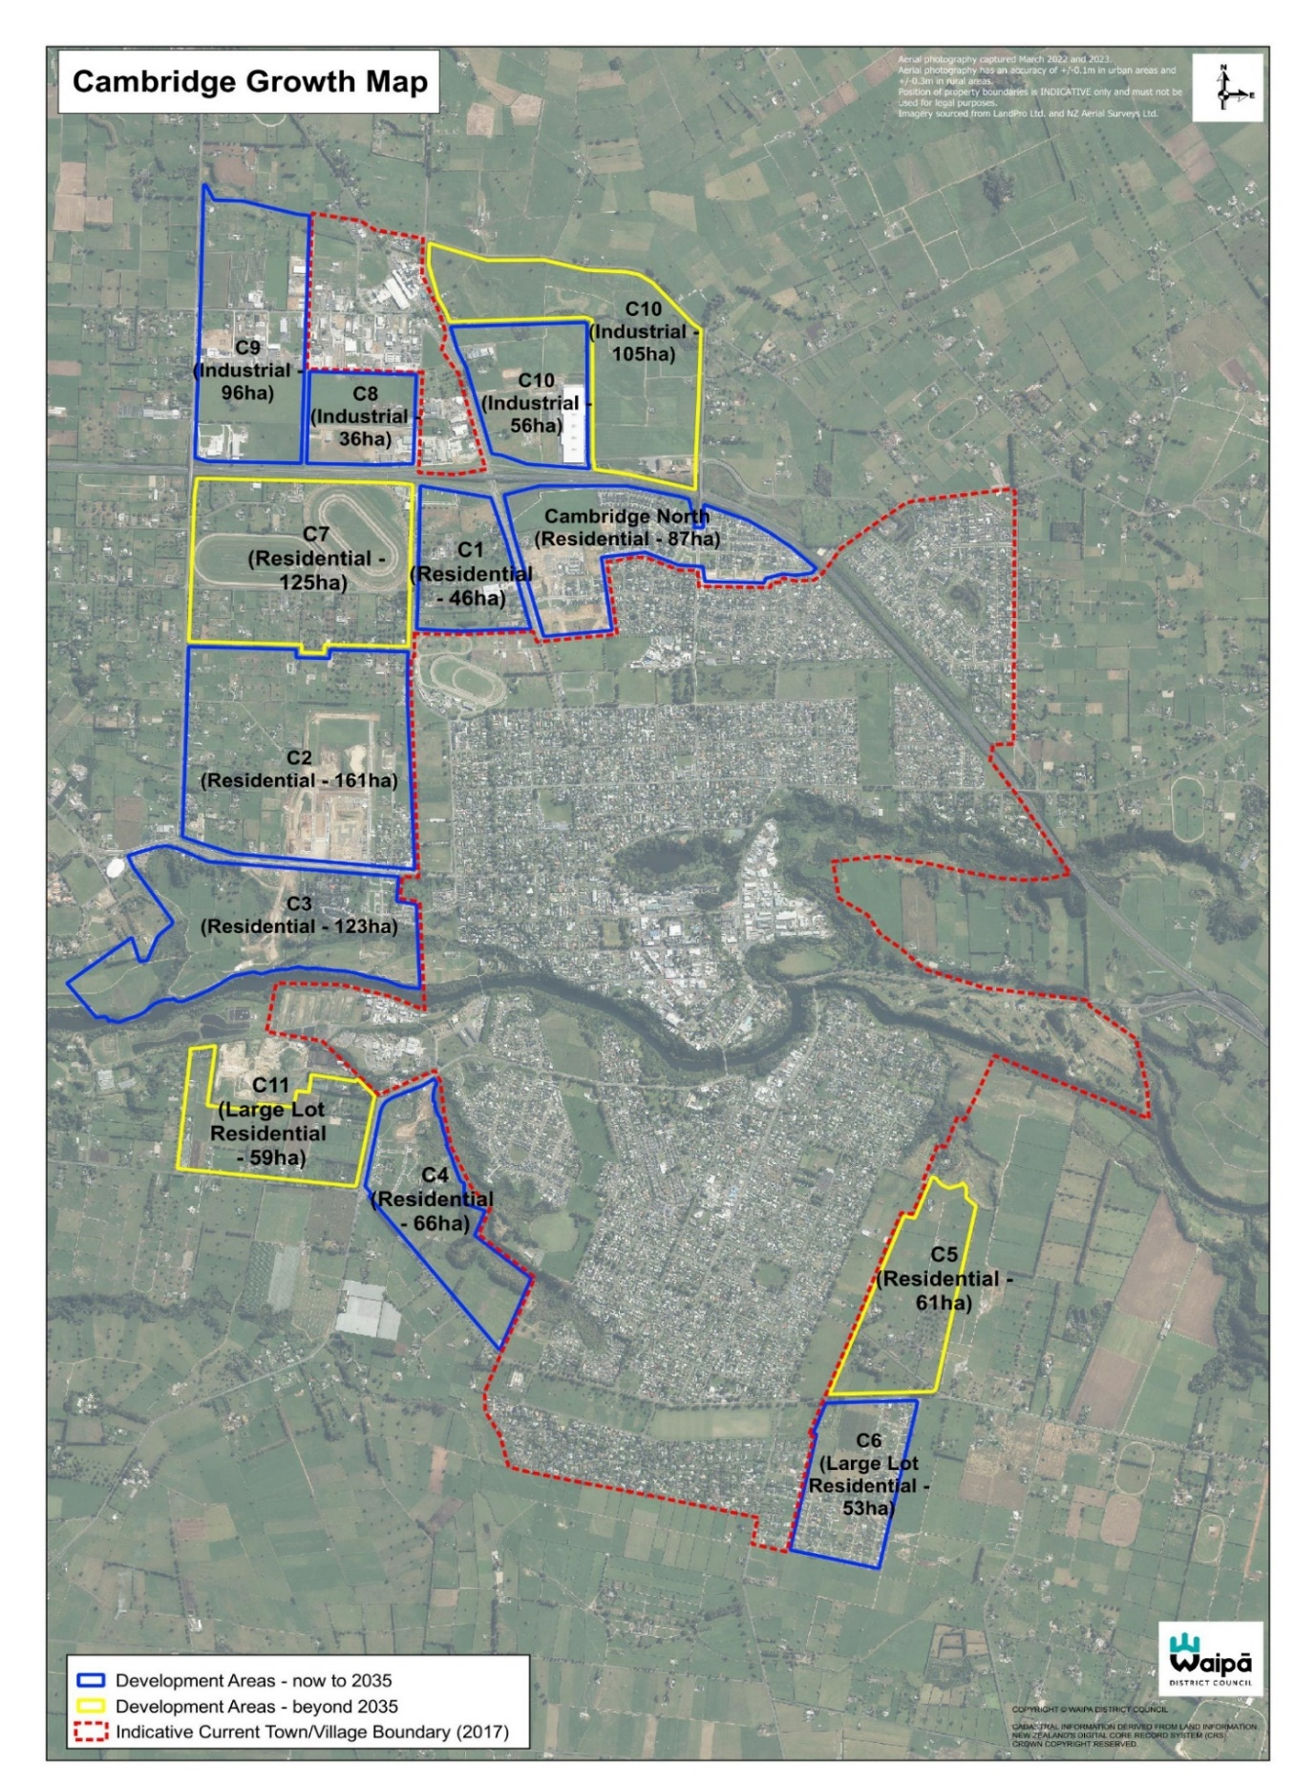

Hamilton Airport Growth Cells
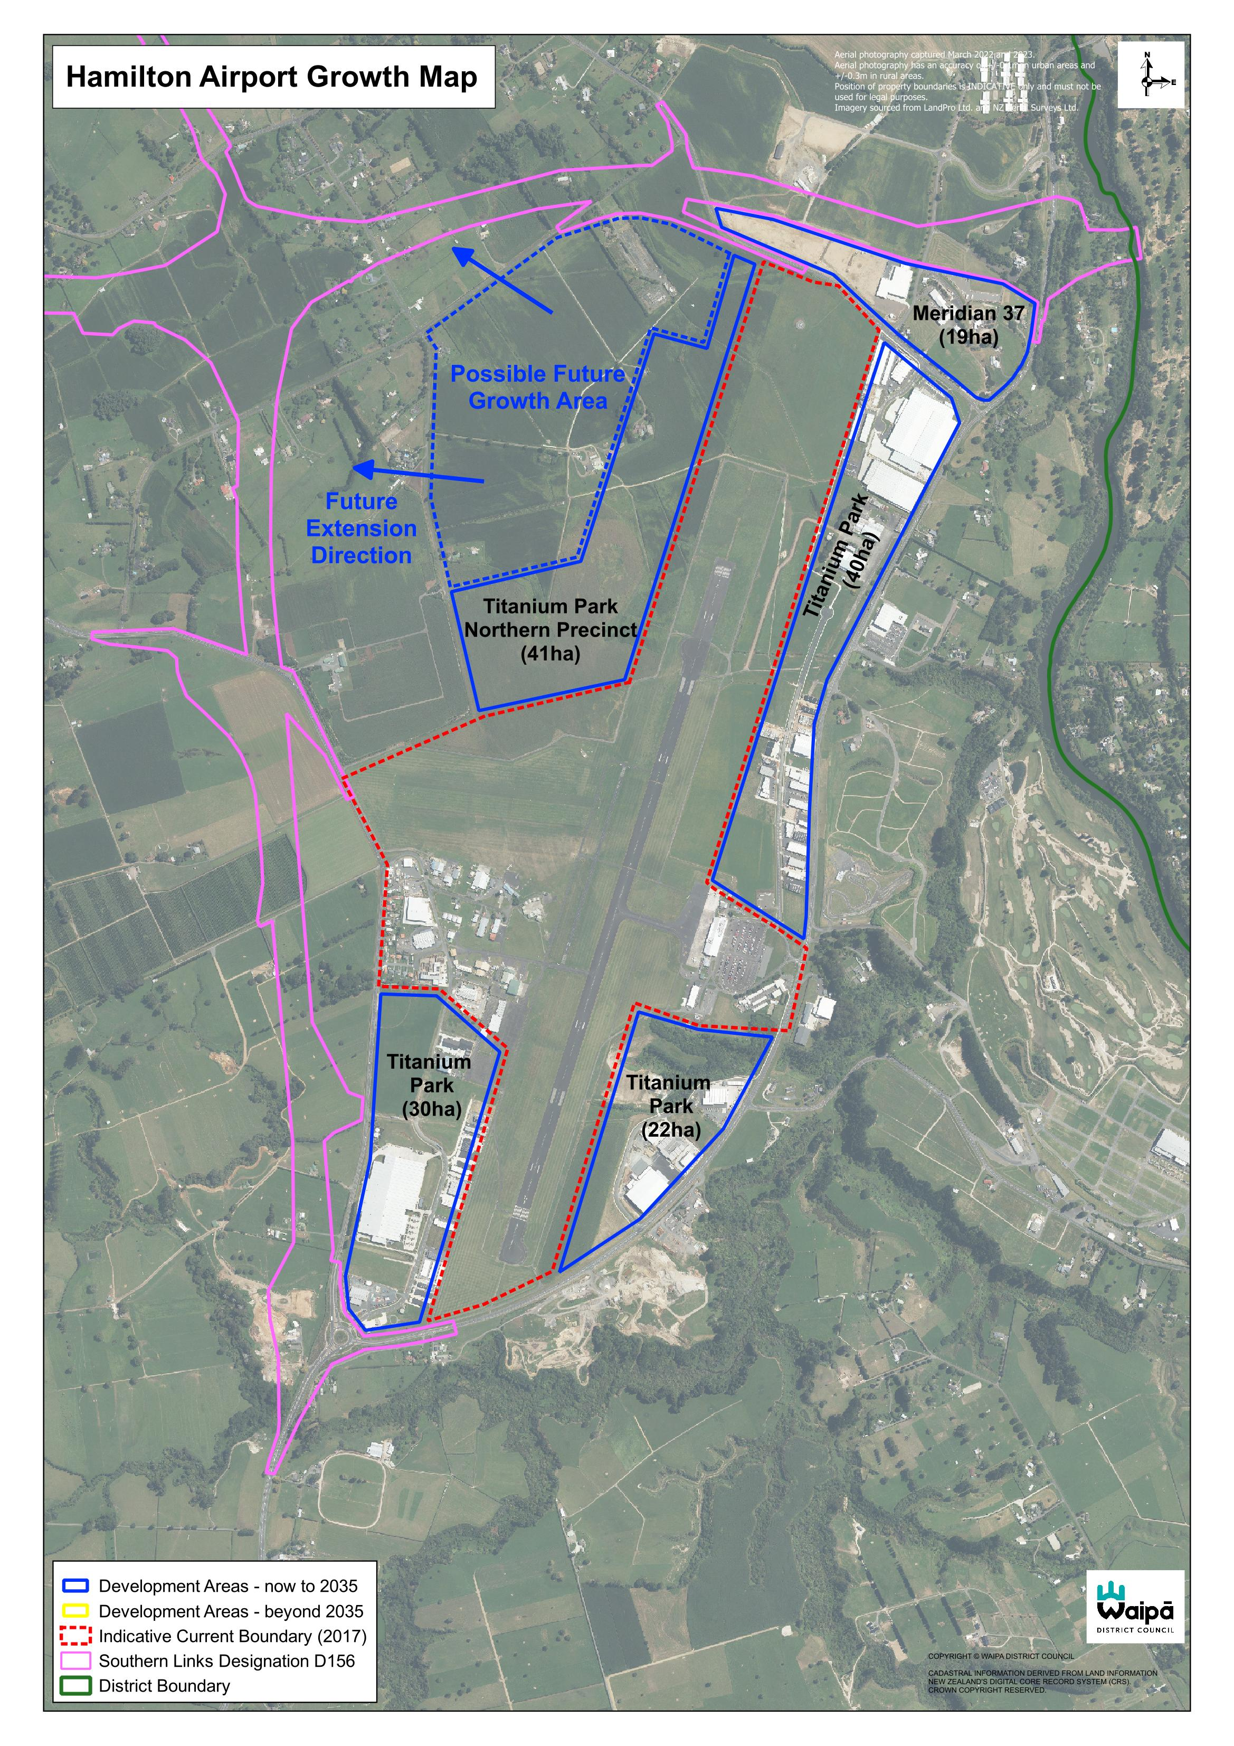

Karāpiro Growth Cells
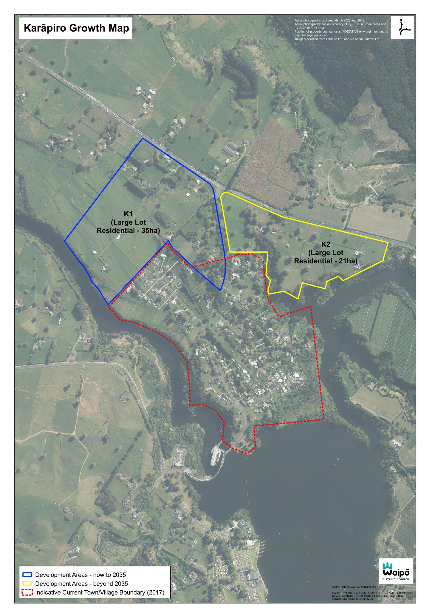

NgĀhinapōuri Growth Cells
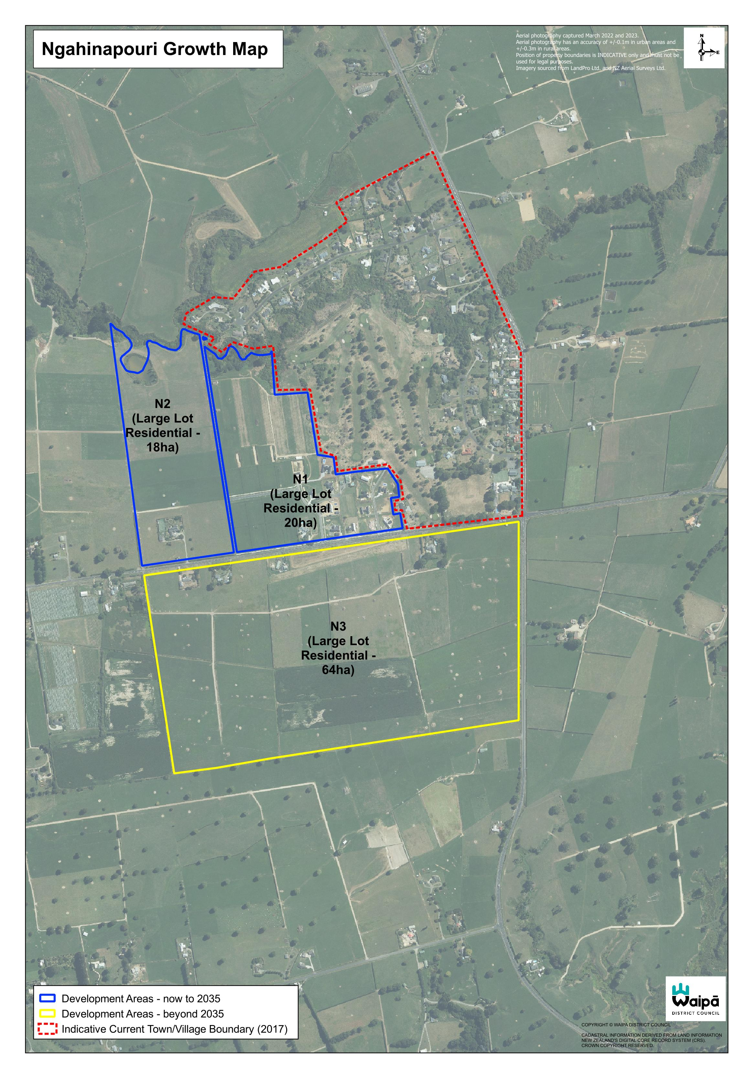

Ohaupō Growth Cells
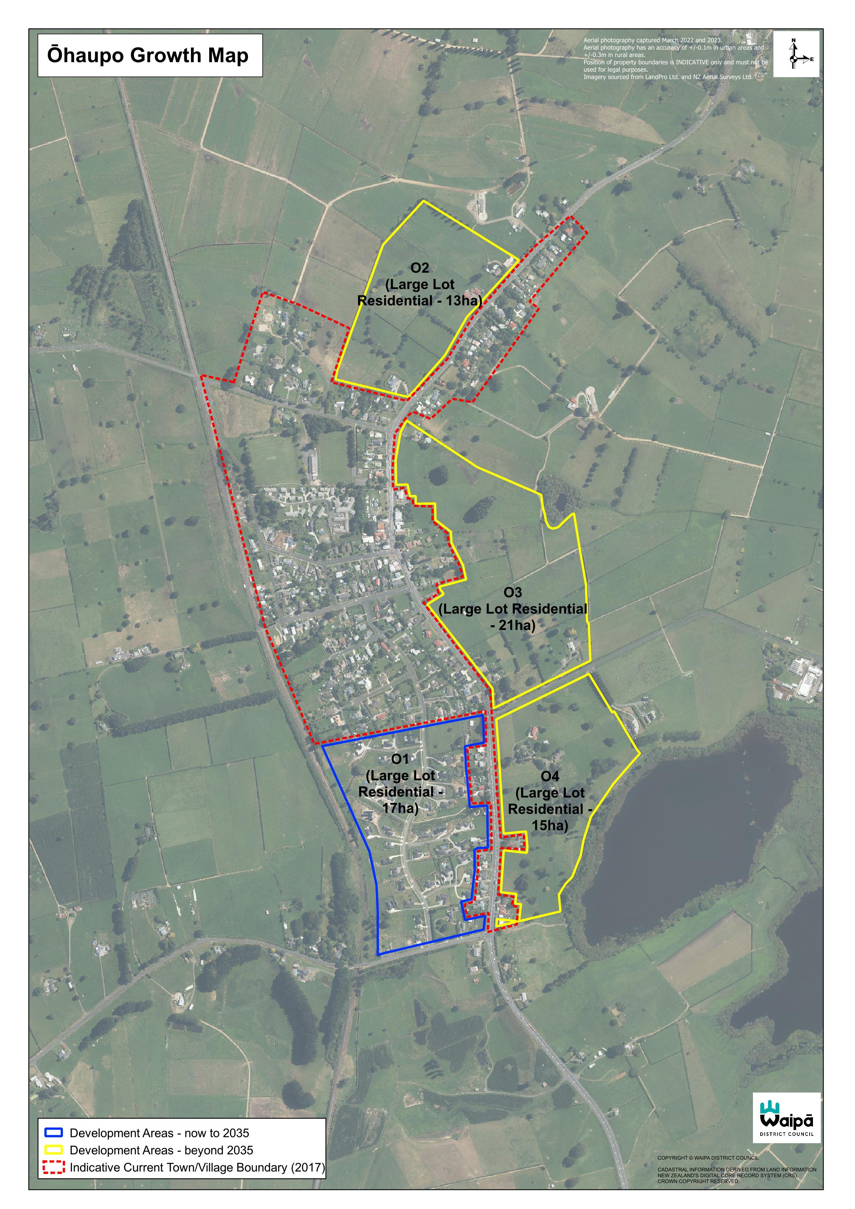

Pirongia
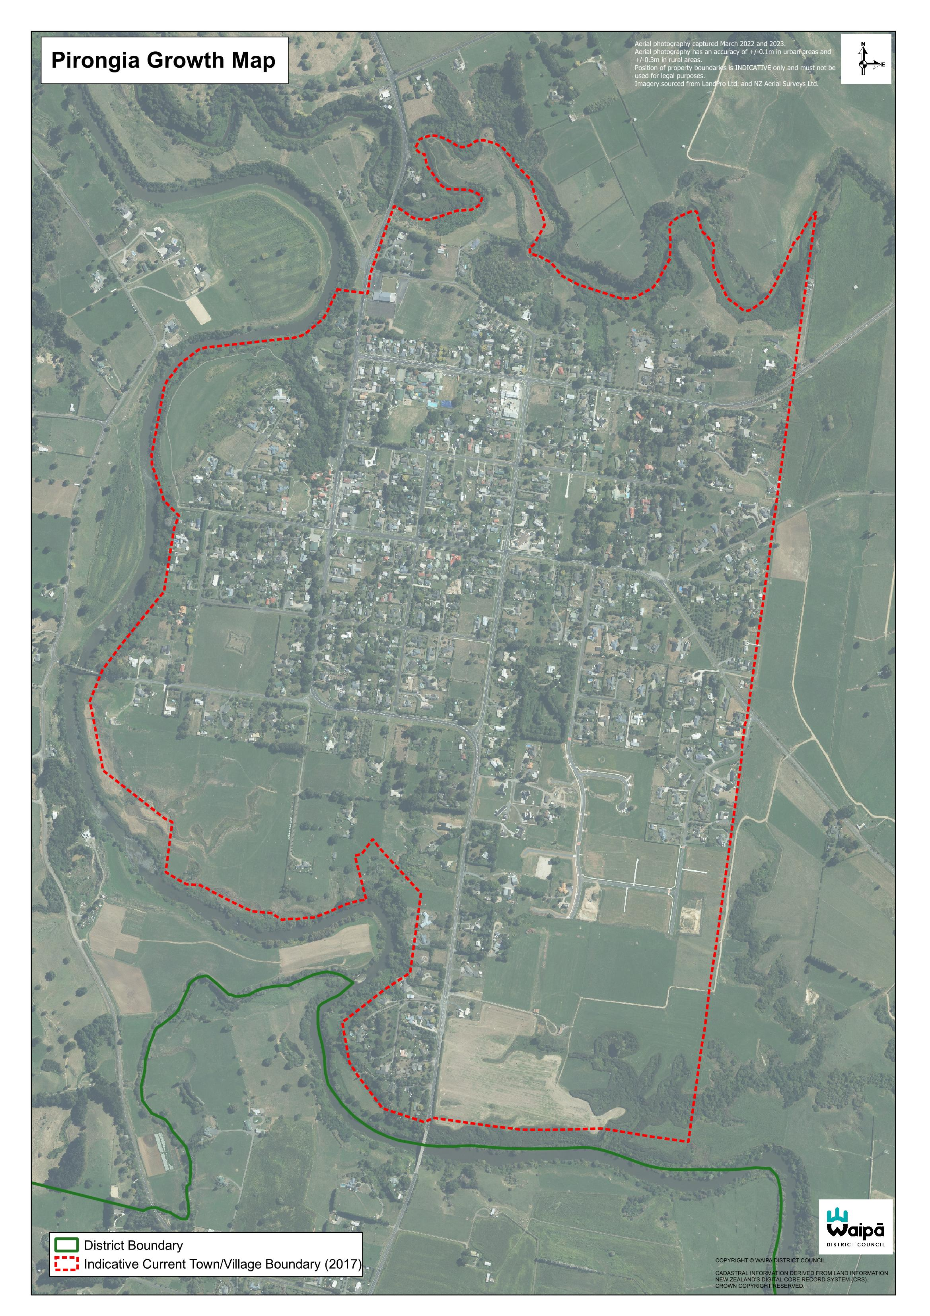

Pukeatua Growth Cells
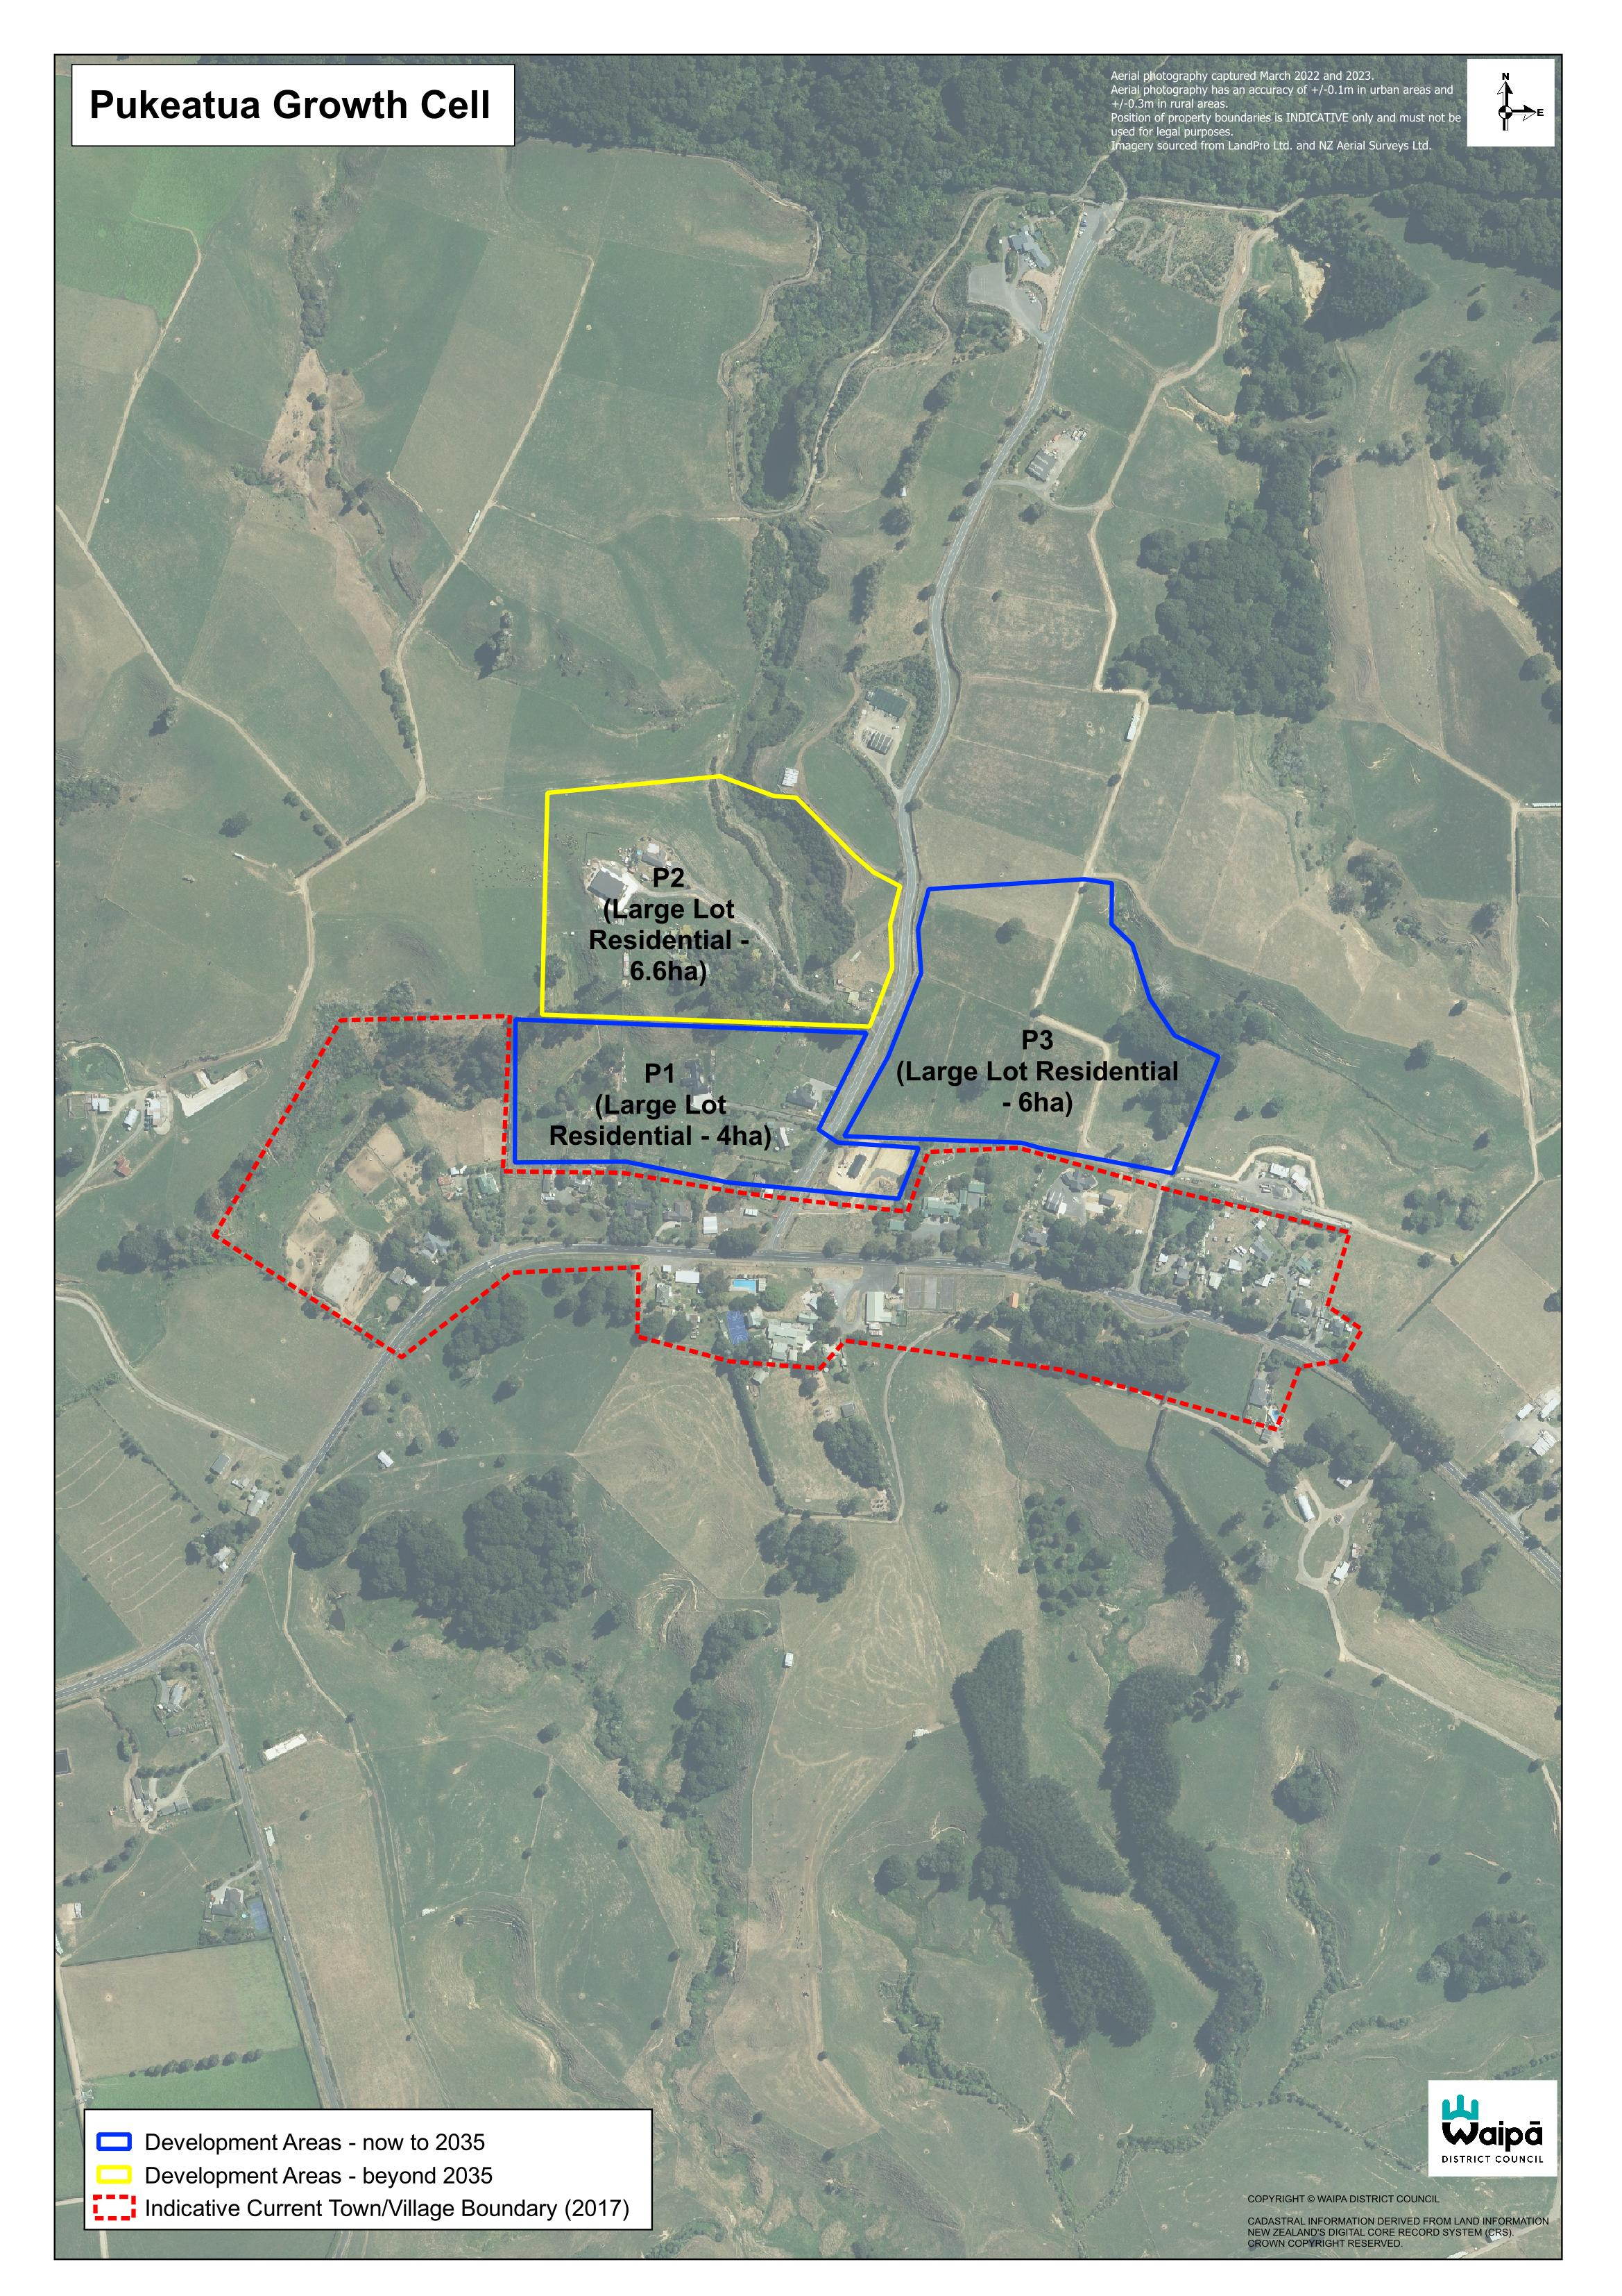

Rukuhia growth cells
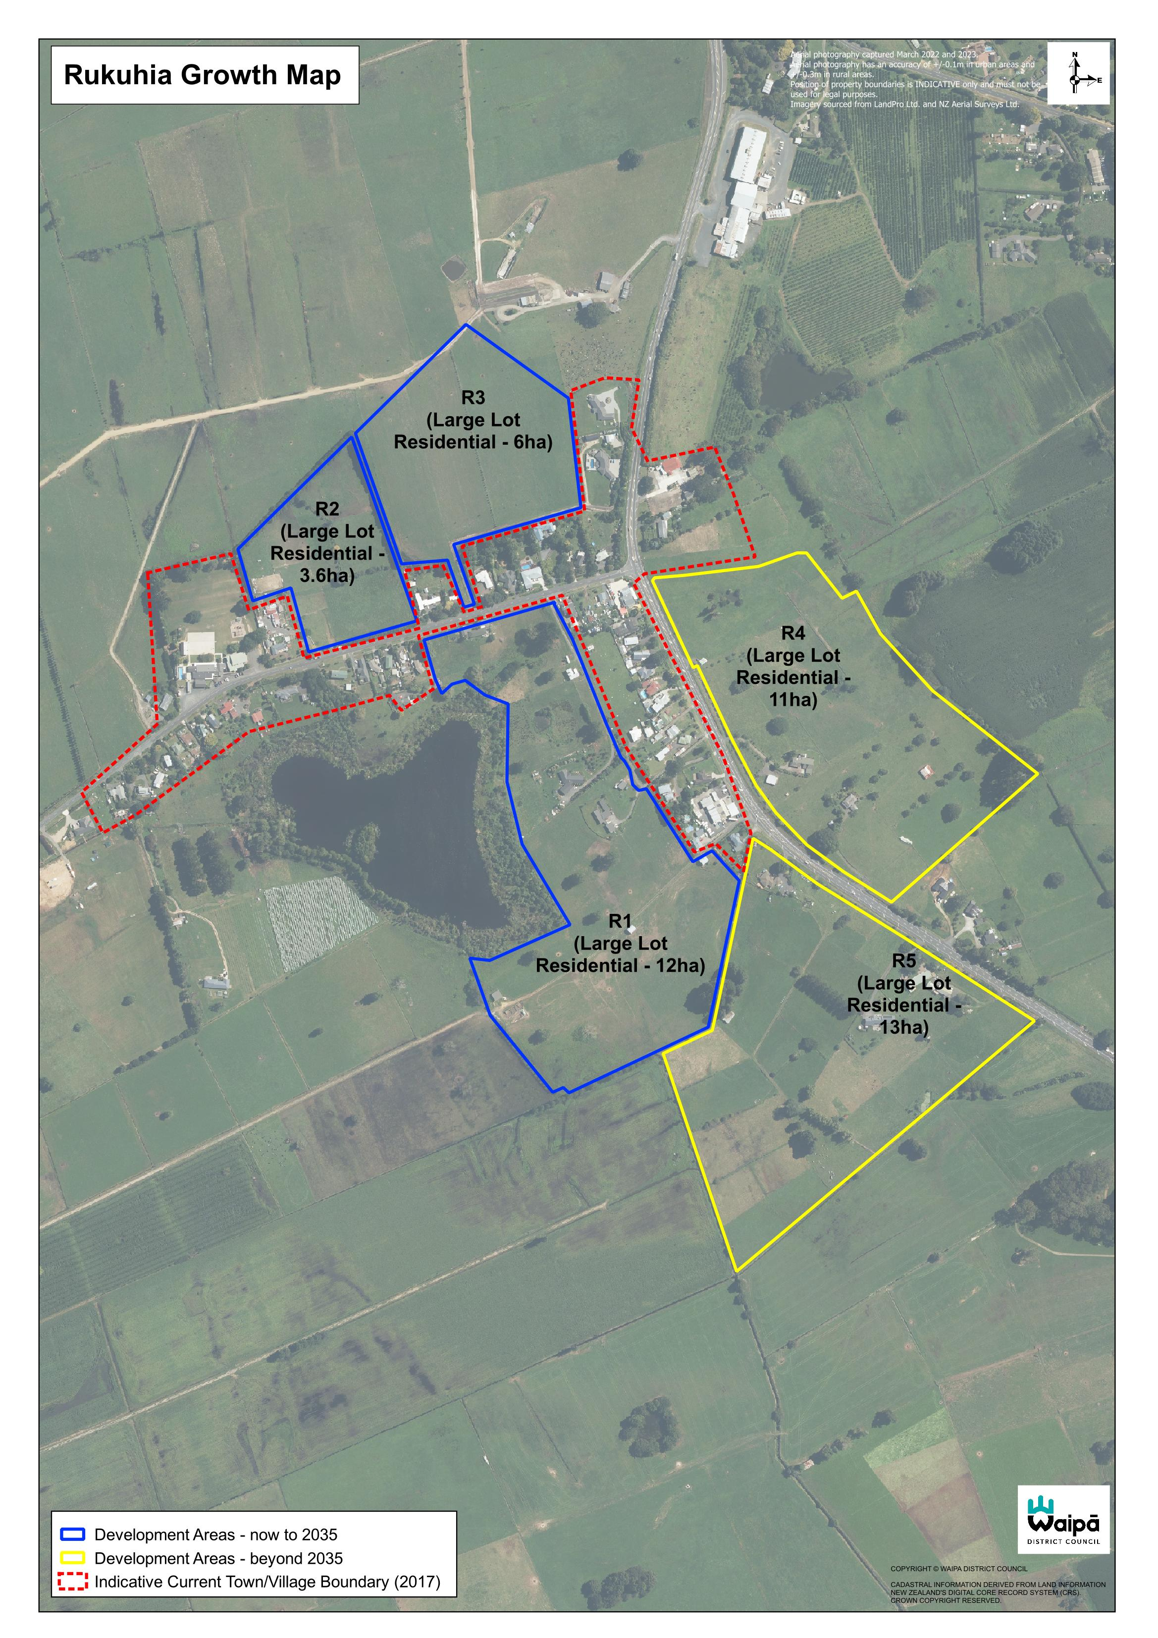

Te awamutu and kihikihi growth cells
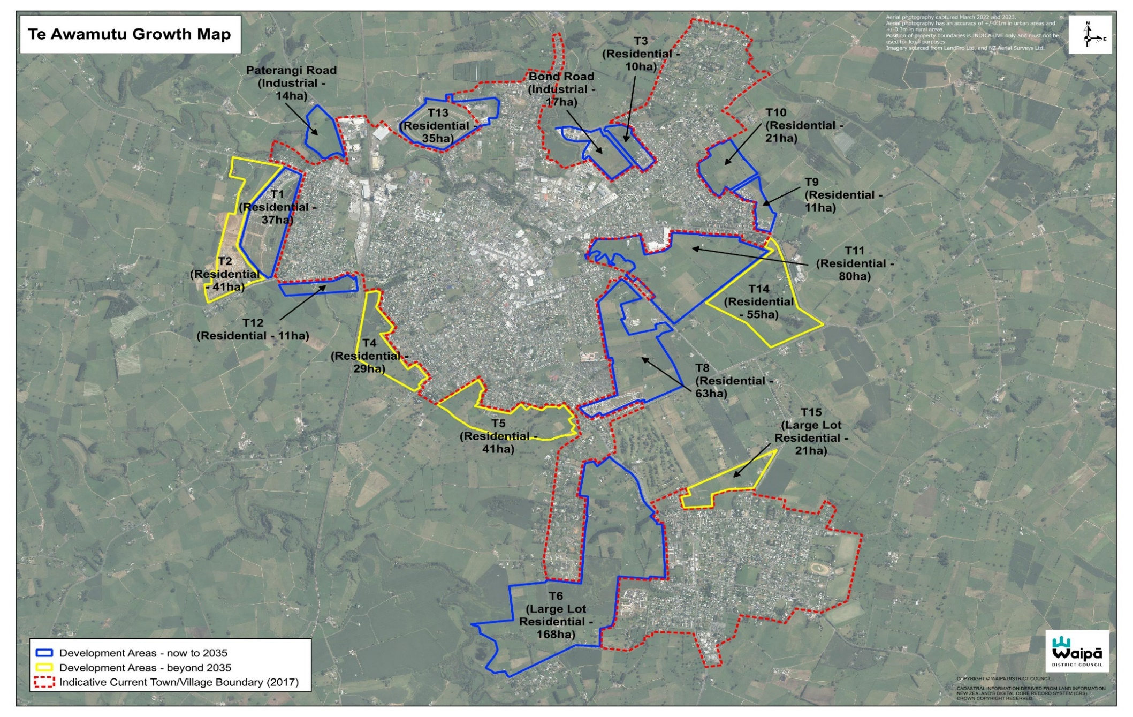

Te Miro growth cells
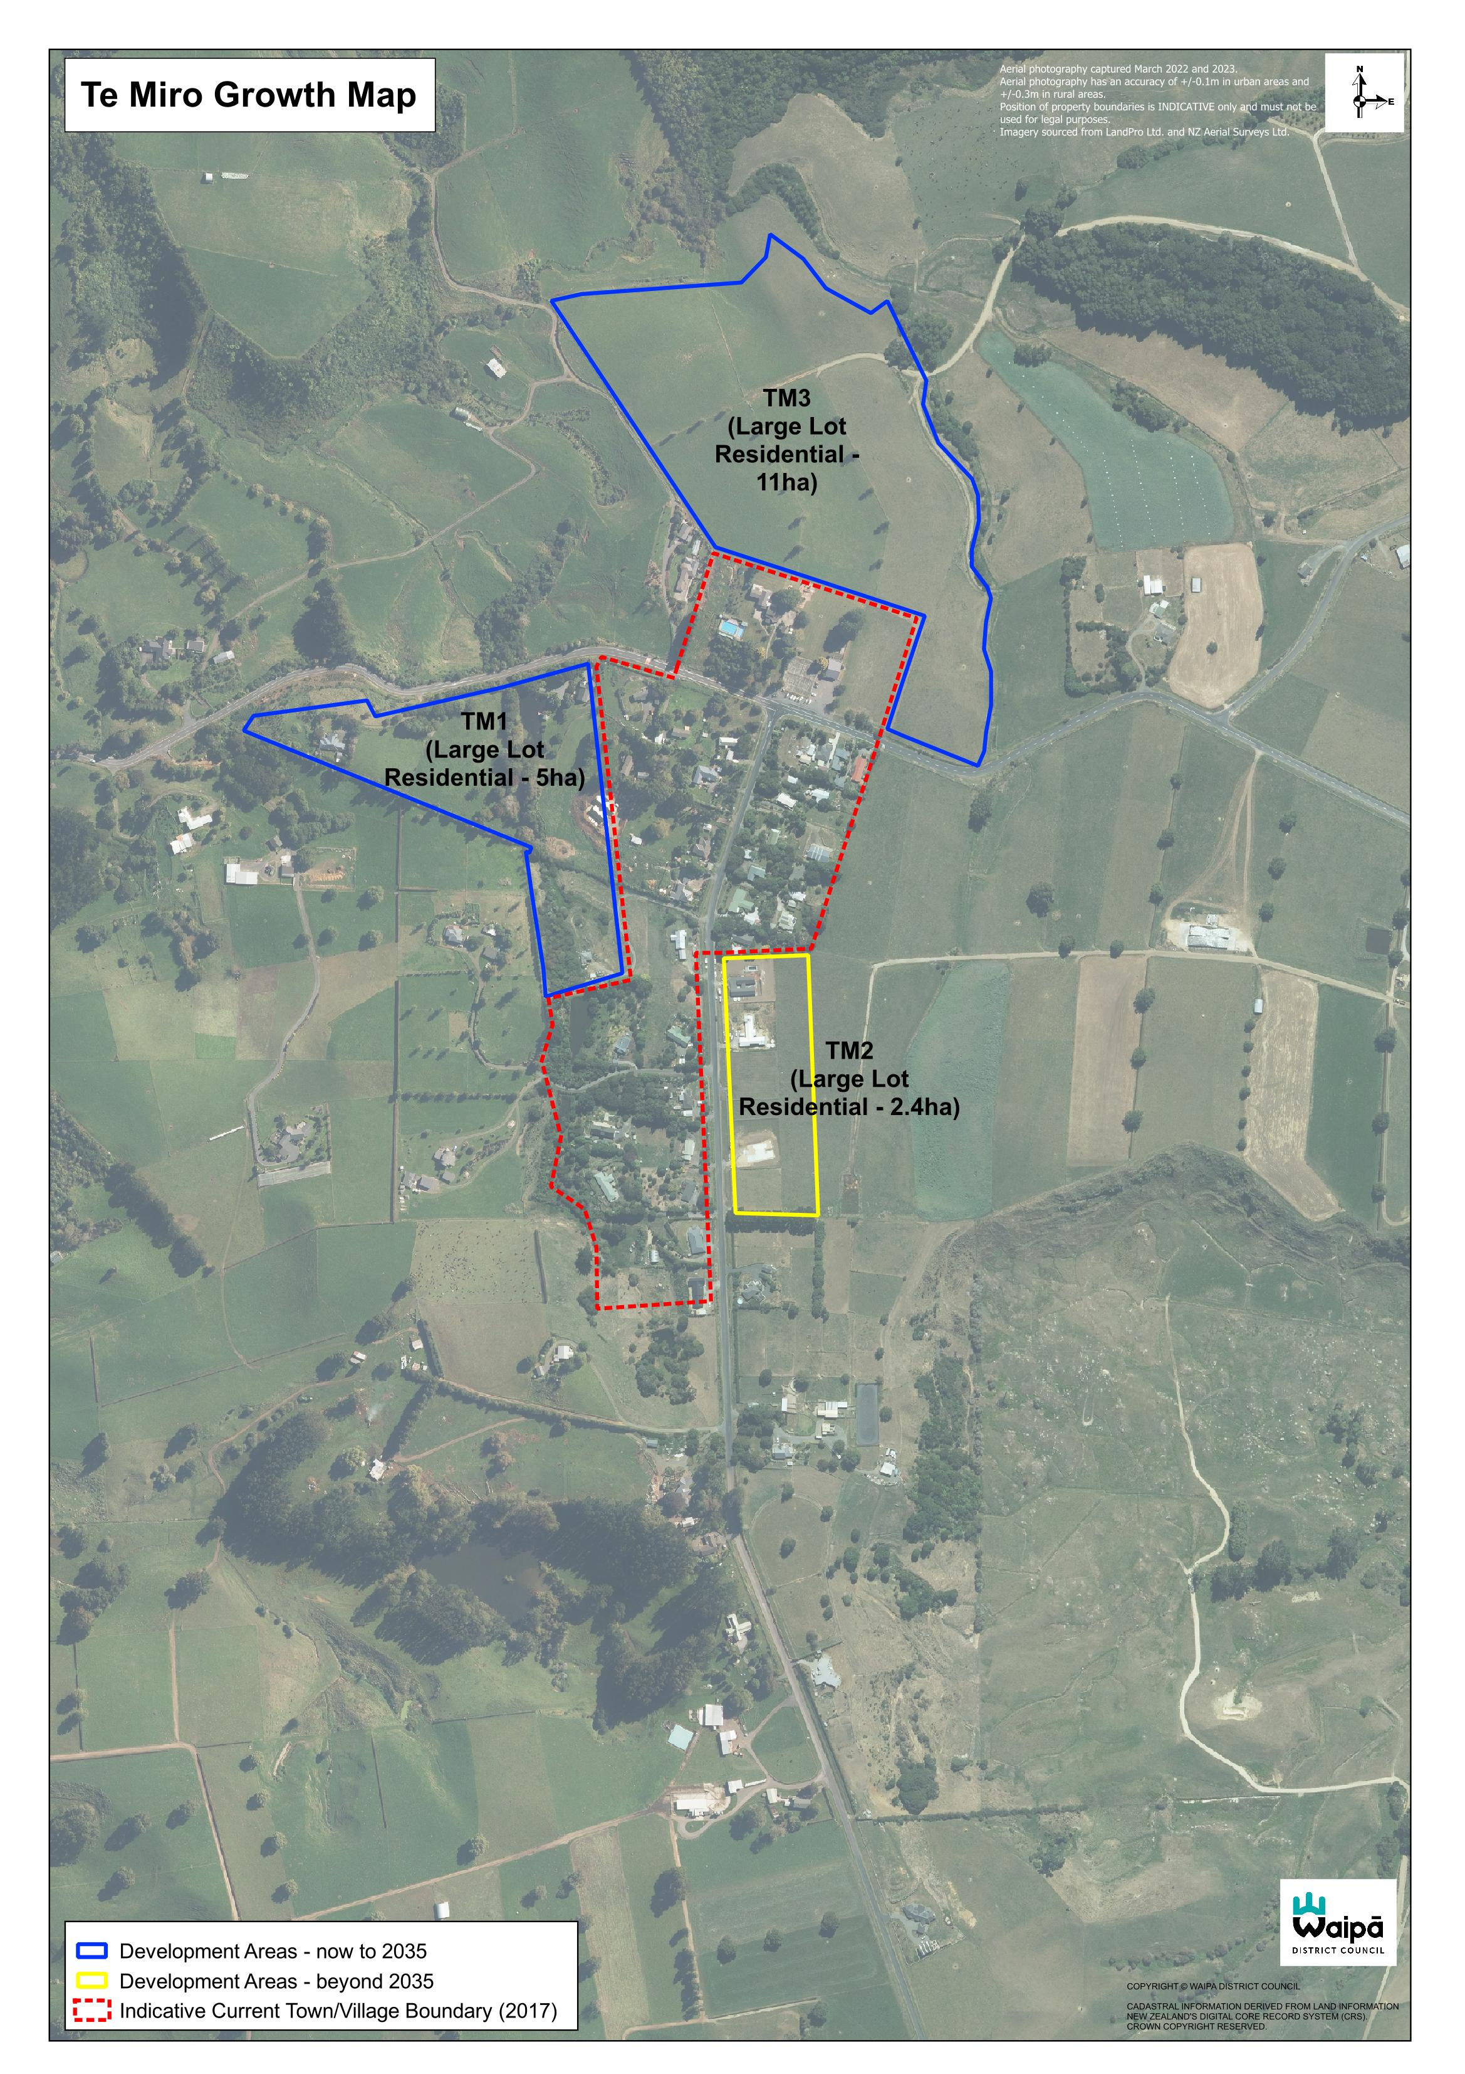

Te Pahu growth cells
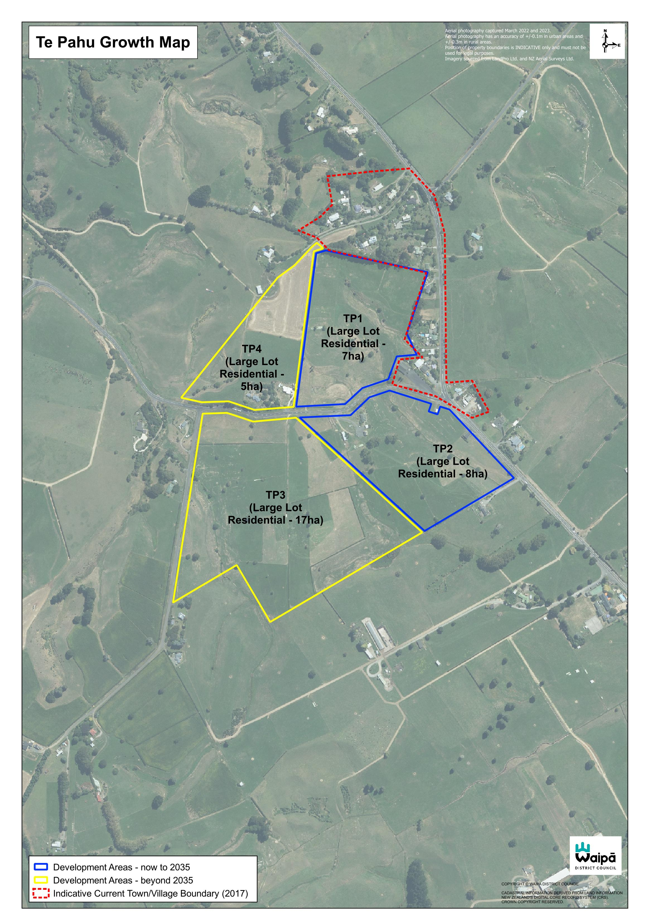

APPENDIX 3 - DEVELOPMENT CONTRIBUTIONS BY FUNDING ARea
Growth Cell/ Funding Area | Quarter (3) Issued (incl. GST) | Quarter (3) recovery (incl. GST) | Total 25/26 Issued (incl. GST) | Total 25/26 recovery (incl. GST) | Total Issued (incl. GST) | Historical Total recovered (incl. GST) | Remain active charges (incl. GST)
Bond Road (Bond Rd/Riverhurst Dr) ** | 0 | 0 | 0 | 0 | 325,405 | 151,700 | 173,705
C1 (Nga Hau Rd) | 0 | 0 | 0 | 1,246,221 | 9,591,096 | 2,492,442 | 7,098,654
C2 (Te Aka Matua Rise) | 2,146,048 | 1,767,773 | 5,626,429 | 2,412,778 | $29,433,988 | 10,368,314 | 19,065,674
C3 (Te Aka Matua Rise) | 401,329 | 0 | 770,042 | 126,709 | 26,017,941 | 5,404,347 | 20,613,594
C4 (Silverwood Ln) | 64,691 | 1,608,238 | 3,582,007 | 3,422,245 | 3,682,989 | 3,482,907 | 200,082
C6 (Sunline Dr) | 3,013 | 0 | 24,104 | 0 | 495,709 | 471,605 | 24,104
Cambridge/Karāpiro | 477,912 | 85,783 | 1,480,870 | 525,308 | 11,692,200 | 7,842,707 | 3,849,493
Cambridge North (Norfolk Dr) | 351,157 | 3,430,821 | 794,479 | 4,600,770 | 35,304,146 | 26,870,274 | 8,433,872
Hautapu (Hautapu Rd) | 34,167 | 0 | 95,343 | 355,995 | 2,871,165 | 2,689,542 | 181,623
Kihikihi | 89,418 | 22,450 | 297,859 | 44,222 | 4,913,460 | 4,410,665 | 502,795
Ngāhinapōuri (Pilot Dr) | 0 | 0 | 27,826 | 8,184 | 540,389 | 512,563 | 27,826
Picquet Hill (Wetere Dr) | 20,600 | 0 | 20,259 | 0 | 986,713 | 966,454 | 20,259
Pirongia | 526 | 0 | 11,142 | 15,876 | 1,006,851 | 919,737 | 87,114
Pukerimu | 0 | 755 | 2,757 | 5,285 | 52,019 | 43,210 | 8,809
Rural | 1,612 | 2,210 | 17,216 | 7,094 | 374,124 | 338,279 | 35,845
T1&T2(Pioneer Dr/Manaia Rd) | 0 | 0 | 1,284,672 | 239,263 | 12,766,993 | 4,301,530 | 8,465,463
T3 (Beckett Dr) | 0 | 0 | 0 | 0 | 8,735 | 0 | 8,735
T6 (St Leger Rd) | 29,918 | 0 | 29,918 | 0 | 518,232 | 220,594 | 297,638
T7 (Swarbrick Dr) | 0 | 0 | 0 | 0 | 332,550 | 0 | 332,550
T8 (Swarbrick Dr) | 0 | 0 | 16,578 | 0 | 1,258,503 | 1,090,249 | 168,254
T11 (Waipiko Dr) | 34,218 | 0 | 34,218 | 0 | 2,675,626 | 1,337,856 | 1,337,770
Te Awamutu | 288,027 | 53,334 | 732,333 | 333,157 | 10,846,063 | 6,600,428 | 4,245,635
Total | 3,942,636 | 6,971,364 | 14,848,052 | 13,343,107 | 155,694,897* | 80,515,403* | 75,179,494*

*Note: that any discrepancy between total issued and total recovered, will be the system processing current payments and Development Agreements.
**Road names can be searched via Council maps available on our website, utilising search by road name.

Appendix 4: Overall Building Trends

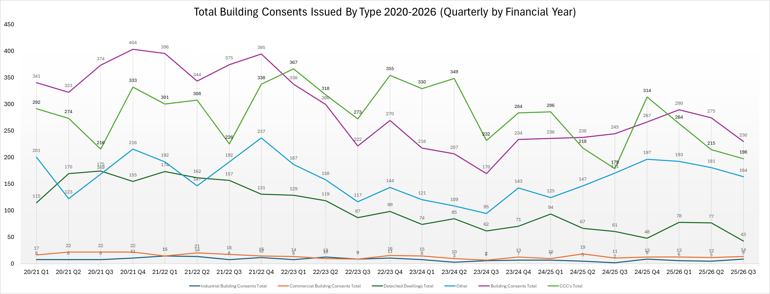

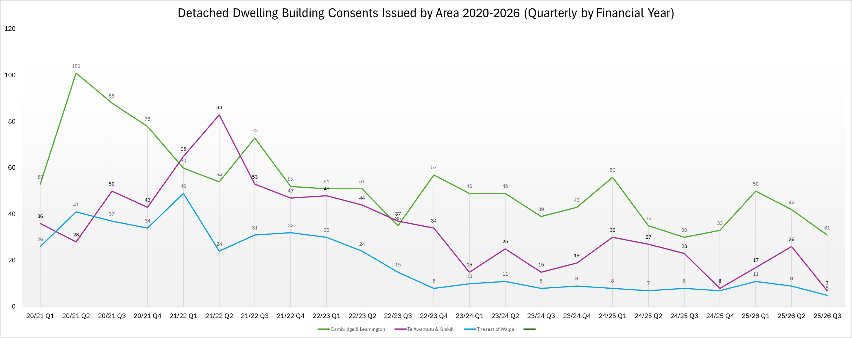

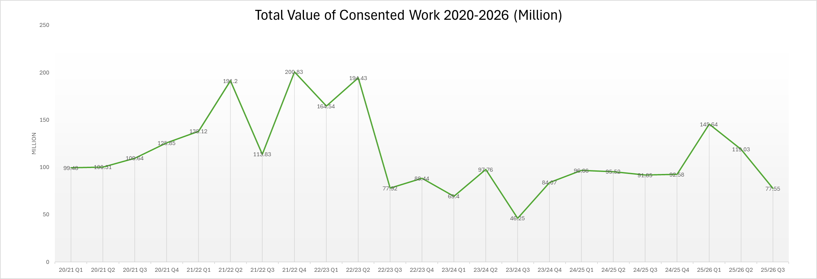

aPPENDIX 5: Quarterly Compliance statistics 25/26

 |  | 1 Jul - 30 Sep | 1 Oct – 31 Dec | 1 Jan – 31 Mar | 1 Apr – 30 Jun | Total
Resource consents
Number of complaints |  | 14 | 22 | 16 |  | 52
Number of warnings |  | 4 | 7 | 9 |  | 20
District Plan
Number of complaints |  | 36 | 85 | 75 |  | 196
Number of warnings |  | 12 | 27 | 24 |  | 63
RMA / Bylaw breaches / complaints
Parking complaints |  | 92 | 87 | 78 |  | 257
Warning letters |  | 191 | 30 | 23 |  | 244
Infringement tickets |  | 342 | 168 | 215 |  | 725
Fire and smoke complaints |  | 21 | 13 | 8 |  | 42
Public Health / Nuisance complaints |  | 6 | 10 | 3 |  | 19
Litter and illegal dumping complaints |  | 32 | 58 | 30 |  | 120
Litter and illegal dumping infringement notices |  | 12 | 13 | 12 |  | 37
Overhanging tree complaints |  | 11 | 17 | 18 |  | 46
Overhanging tree warning letters |  | 11 | 17 | 18 |  | 46
RMA / Bylaw Breaches
Illegal signs removed |  | 0 | 0 | 0 |  | 0
Swimming Pool Barriers
Pool barrier enquiries |  | 23 | 27 | 18 |  | 68
Pool barrier inspections |  | 134 | 166 | 117 |  | 417
Noise
Excessive noise complaints | Total (all wards) | 135 | 210 | 230 |  | 575
Excessive noise complaints | Cambridge | 45 | 92 | 107 |  | 244
Excessive noise complaints | Maungatautari | 1 | 1 | 1 |  | 3
Excessive noise complaints | Pirongia & Kakepuku | 8 | 15 | 12 |  | 35
Excessive noise complaints | Te Awamutu & Kihikihi | 81 | 102 | 110 |  | 293
Unreasonable noise |  | 20 | 24 | 33 |  | 77
Written noise directives issued |  | 1 | 0 | 6 |  | 7
Verbal noise directives issued |  | 12 | 15 | 21 |  | 48
Animal control
Total complaints and requests for service |  | 1135 | 869 | 905 |  | 2909
Barking dogs |  | 121 | 96 | 116 |  | 333
General info / admin |  | 648 | 468 | 431 |  | 1547
Reported lost dogs |  | 52 | 32 | 38 |  | 122
Animal complaints (dogs and stock) |  | 262 | 227 | 263 |  | 752
Animal Welfare (dogs and stock) |  | 13 | 17 | 16 |  | 46
Dog attack or bite (on person or animal) |  | 23 | 26 | 36 |  | 85
Animal control – Dogs
Registered (total) |  | 8319 | 8797 | 8994 |  | 8994
Un-registered (total) |  | 1054 | 538 | 468 |  | 468
Impounded |  | 54 | 52 | 58 |  | 164
Re-homed |  | 16 | 15 | 25 |  | 56
Claimed 1 |  | 32 | 26 | 24 |  | 82
Euthanased 1 |  | 5 | 1 | 5 |  | 11
Stolen / escaped |  | 1 | 0 | 0 |  | 1
In pound / foster care at end of quarter |  | 0 | 10 | 4 |  | 4
Infringement notices issued |  | 8 | 11 | 18 |  | 37
Menacing dog classification (total) |  | 108 | 107 | 109 |  | 109
Dangerous dog classification (total) |  | 4 | 4 | 4 |  | 4
Food, Health and Alcohol Inspections
Health Premises |  | 0 | 2 | 2 |  | 4
Food Act Audits |  | 58 | 72 | 59 |  | 189
Licensed Premises |  | 8 | 5 | 17 |  | 30
Premises Checked in CPO |  | 0 | 39 | 0 |  | 39
Breaches detected (selling alcohol to minors) |  | 0 | 2 | 1 |  | 3
Food, Health and Alcohol Complaints
Food / Health Premises |  | 4 | 0 | 4 |  | 8
Licensed Premises |  | 1 | 2 | 2 |  | 5
Food, Health and Alcohol Licenses
Food Control Plan (total) |  | 237 | 239 | 233 |  | 233
National Program (food) |  | 96 | 97 | 90 |  | 90
Number of current on-licences (total) |  | 77 | 79 | 78 |  | 78
Number of current off-licences (total) |  | 39 | 39 | 38 |  | 38
Number of current club licenses (total) |  | 27 | 27 | 27 |  | 27
Number of current BYO (total) |  | 1 | 1 | 1 |  | 1
Number Health Premises (total) |  | 8 | 8 | 9 |  | 9
District Licensing Committee
Club licences and renewals |  | 4 | 4 | 3 |  | 11
Off licences and renewals |  | 8 | 1 | 3 |  | 12
On licences and renewals |  | 10 | 7 | 9 |  | 26
Special licences |  | 41 | 28 | 22 |  | 91
Manager Certificates and renewals |  | 66 | 78 | 62 |  | 206
Temporary Authority |  | 2 | 1 | 3 |  | 6
Hearings |  | 2 | 0 | 0 |  | 2

Provisional figures pending outcome of dogs currently impounded.

